|  |  |  |  |  |
| --- | --- | --- | --- | --- |
| **Goggles [brand/name]** | **ITEM CODE** | **Field Hockey ASTM 2713** |  |  |
| Bangerz Elite | [LHSE](https://www.longstreth.com/Bangerz-Elite-Anti-Fog-Goggle/productinfo/LHSE/) | Approved |
| Bangerz | HS 3700LT | Approved |
| Bangerz Sunglass Eyeguard | [LHS7900](https://www.longstreth.com/Bangerz-Sunglasses-Eyeguard-_-Goggles/productinfo/LHS7900/) | Approved |
| Bangerz Goggle | LHPG | Approved |
| Bangerz Sleek Fitting Eyeguard | LHS5500 | Approved |
| Bangerz Sleek Fitting Eyeguard Youth | [LHS6000Y](https://www.longstreth.com/Bangerz-Sleek-Fitting-Eyeguard-Youth/productinfo/LHS6000Y/) | Approved |
| Bangerz Over the Glasses | [LHOGG](https://www.longstreth.com/Bangerz-Over-Glasses-Goggle/productinfo/LHOGG/) | Approved |
| Cascade Iris | Mini pro | Approved |
| Cascade Polyarc | [LCPARC](https://www.longstreth.com/Cascade-Polyarc-Lacrosse-Goggle/productinfo/LCPARC/) | Approved |
| STX 2 SEE Pro TI Dual Sport Goggle | STXGFTP | Approved |
| STX 2 SEE Dual Sport Goggle | [STXFHG](https://www.longstreth.com/STX-2-See-Field-Hockey-Or-Lacrosse-Goggle/productinfo/STXFHG/) | Approved |
| STX 2 SEE YOUTH Dual Sport Goggle | [STXFHGY](https://www.longstreth.com/STX-2-See-Youth-Field-Hockey-or-Lacrosse-Goggle/productinfo/STXFHGY/) | Approved |
| STX Rookie Goggle | [LSGGLXR](https://www.longstreth.com/STX-Rookie/productinfo/LSGGLXR/) | Approved |
| Brine Vantage 2 Field Hockey or Lacrosse Goggle | [LBVAN2](https://www.longstreth.com/Brine-Vantage-2-Field-Hockey-or-Lacrosse-Goggle/productinfo/LBVAN2/) | Approved |
| Harrow-X Vision Dual Sport | HHXVG | Approved |
| Under Armour Illusion 2 Wire Goggles | [UAI2WLFG](https://www.longstreth.com/prodinfo.asp?number=UAI2WLFG) | Approved |

In order for wire goggles to be legal for girl's field hockey, they must have a wire bar that stretches vertically through the goggle. The comparison between girl’s field hockey and girl's lacrosse goggles can be found in the image below.

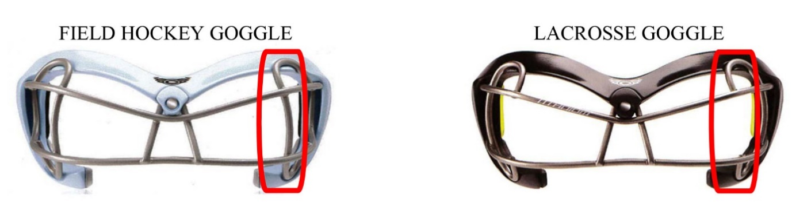

Rule 1.6.5 states: All field players shall wear eye protection that meets *the ASTM standard for field hockey at the time of manufacture.*

Note: Effective January 1 2019, all eye protection shall be permanently labeled with the ASTM 2713 standard for field hockey at time of manufacture.

Therefore, this is no longer a PIAA Modification to the 2018 NFHS Rule Book. The 2018 PIAA Modification to protective eye wear is for prescription eyewear that is necessary for players to wear to participate in Field Hockey.

It was unanimously voted to adopt the recommendation of the Sports Medicine Advisory Committee to modify NFHS Field Hockey Rule 1-6-5 to permit players with prescription glasses to wear protective eyewear that meets the ASTM F803 standard.

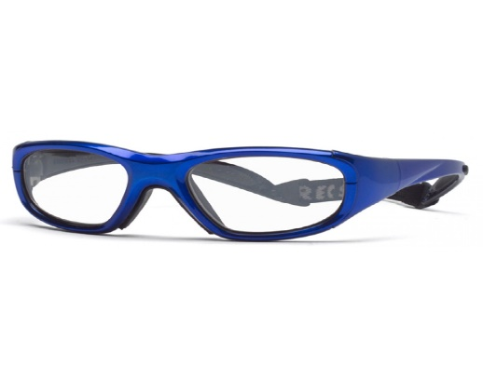Commonly called “spec recs” – they come with a band to hold the glasses to the head and are marked as Meet ASTM F803 standard.

If a player is wearing Prescription ASTM F803 Recreational Sports Glasses, there is no requirement for the player to wear additional protective eyewear over the prescription eyewear.